# Step 1:

**P**

**eople**

**will**

**click here”Do you have coupon code? ”:**

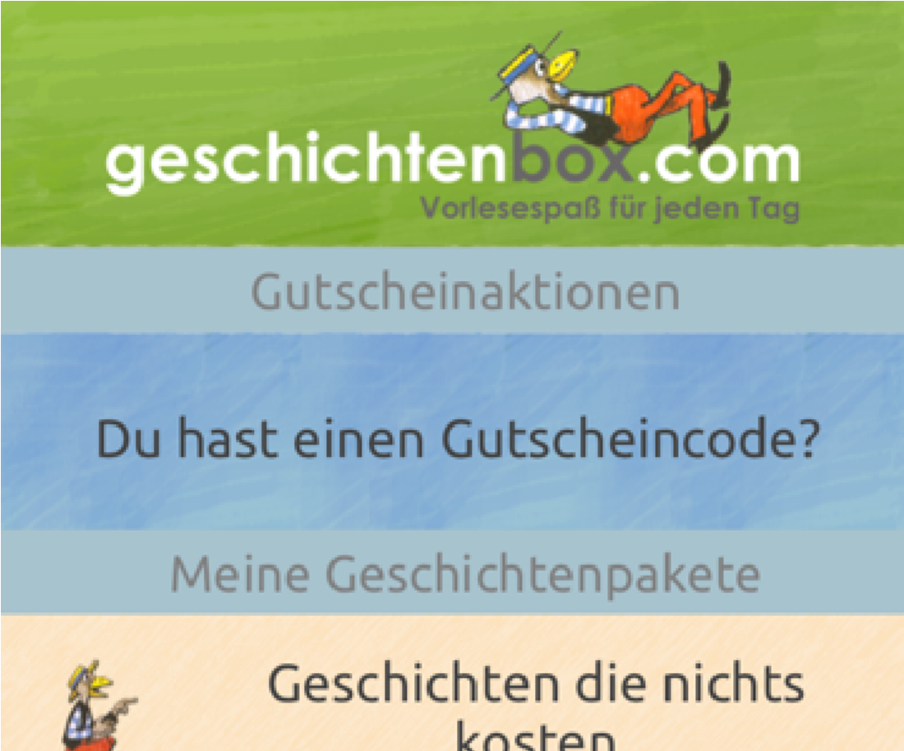

# Step 2:

**People will enter voucher code:**

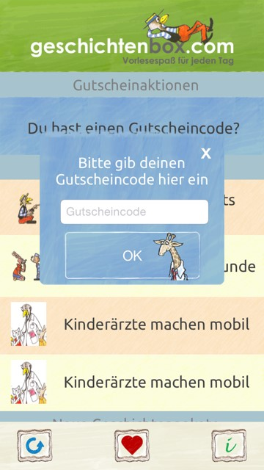

# Step 3:

As soon as they enter voucher code a similar field should pop up where they are asked to enter their email and a password (this step has to be connected to geschichtenbox website

Please register so that you get more free stories from the geschichtenbox.com !

Field for EMAIL ADRESS

Field for PASSWORD

OK BUTTON

BUTTON if they dont want to register

# Step 4:

People enter the “Kinderärzte Machen mobil” package where they can choose between the section.Can look like here and if the clicks on it they will come to the different sections

|  |
| --- |
| **PLACE FOR PARTNERLOGO** |
| **KINDERÄRZTE MACHEN MOBIL** |
| **INFOS.....** |

|  |
| --- |
| STORY VIDEO |

|  |
| --- |
| STORIES TO READ |

|  |
| --- |
| STORIES TO LISTEN |

|  |
| --- |
| INFOS |

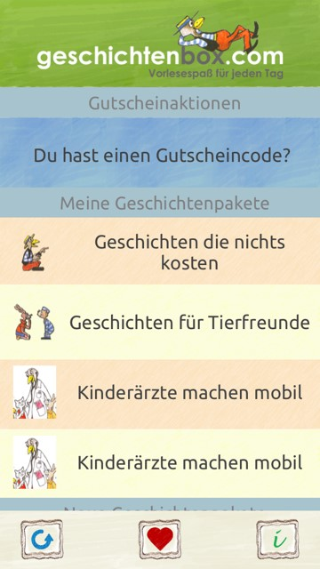**DIE PAKETE**